Direct Preference Optimization

RLHF

- SFT Phase
Train Self fine tune model: πSFT
- Reward Modelling Phase
p∗(y1​>y2​∣x)=exp(r∗(x,y1​))+exp(r∗(x,y2​))exp(r∗(x,y1​))​

- RL Fine-Tuning Phase

People actually used this as reward to avoid compute KL

DPO
Optimal policy
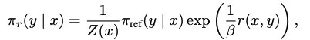

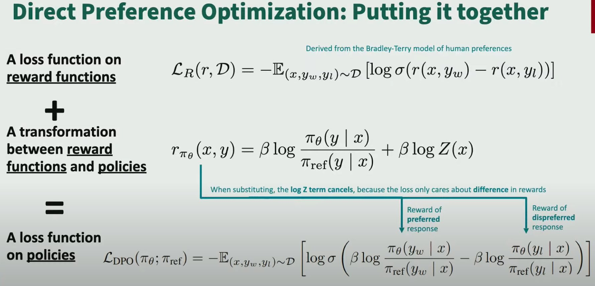

Code/Training

Code implementation
https://github.com/eric-mitchell/direct-preference-optimization/blob/main/trainers.py#L76
def dpo_loss(policy_chosen_logps: torch.FloatTensor,
policy_rejected_logps: torch.FloatTensor,
reference_chosen_logps: torch.FloatTensor,
reference_rejected_logps: torch.FloatTensor,
beta: float,
reference_free: bool = False) -> Tuple[torch.FloatTensor, torch.FloatTensor, torch.FloatTensor]:
"""Compute the DPO loss for a batch of policy and reference model log probabilities.
Args:
policy_chosen_logps: Log probabilities of the policy model for the chosen responses. Shape: (batch_size,)
policy_rejected_logps: Log probabilities of the policy model for the rejected responses. Shape: (batch_size,)
reference_chosen_logps: Log probabilities of the reference model for the chosen responses. Shape: (batch_size,)
reference_rejected_logps: Log probabilities of the reference model for the rejected responses. Shape: (batch_size,)
beta: Temperature parameter for the DPO loss, typically something in the range of 0.1 to 0.5. We ignore the reference model as beta -> 0.
reference_free: If True, we ignore the _provided_ reference model and implicitly use a reference model that assigns equal probability to all responses.
Returns:
A tuple of three tensors: (losses, chosen_rewards, rejected_rewards).
The losses tensor contains the DPO loss for each example in the batch.
The chosen_rewards and rejected_rewards tensors contain the rewards for the chosen and rejected responses, respectively.
"""
pi_logratios = policy_chosen_logps - policy_rejected_logps
ref_logratios = reference_chosen_logps - reference_rejected_logps
if reference_free:
ref_logratios = 0
logits = pi_logratios - ref_logratios
losses = -F.logsigmoid(beta * logits)
chosen_rewards = beta * (policy_chosen_logps - reference_chosen_logps).detach()
rejected_rewards = beta * (policy_rejected_logps - reference_rejected_logps).detach()
return losses, chosen_rewards, rejected_rewards

Training
https://github.com/huggingface/trl/tree/main/examples/research_projects/stack_llama_2/scripts

Appendix

A1: Deriving the optimal policy
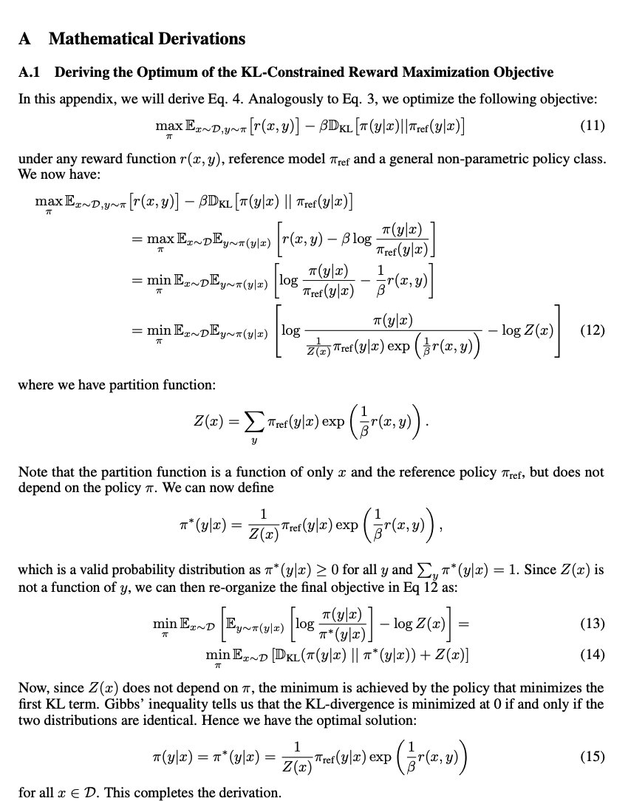

A2: Deriving optimal reward
